Prakhar Saxena

Ilanit Izrailov  Preet Patel

Professor David Augenblick CS 275

September 6th, 2018

NASA NEO - Final Status Report

This past week we have been working on our project, both server and client sides.

An SQL table for ‘object’ was set up.

Detailed table is presented at end of current file.

Our near-earth objects will be stored in the object table, and they will be available to be displayed on the web app to the user’s choice.

We worked on our initial mockup of the web app in attempt of making it more user friendly and fun. Our web app contains a pop up menu, which contains four options in a panel on the left:

1. NEO - add start and end date, then click to display info
2. APOD - click to display Astronomy Picture of the Day
3. Add NEO - user can add an object to SQL table by reference id
4. Added NEOs - look at updated table of objects per user

For ‘add NEO’, a user will be able to add a near-earth object to the table, and have all objects in one place for him to examine later on.

For the APOD, user will also get a link to open the image in a separate page.

Nothing has changed considerably since our original plan, our project is centered around a simple web application to extract and display information from a NASA API to astronomy lovers/fans.

Updated Gantt Chart:

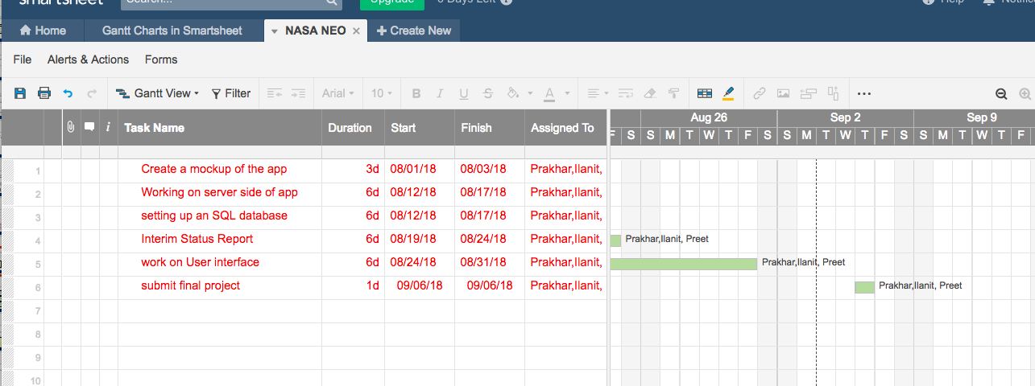

Final Updated Database Schema:

